Purpose: Day 3 ClassWork and Assignment
Date: 23/12/2025
Author: Vinayak Majhi
ID: 58618

Classwork
(NotePad)

Conditional

Q.1. take name an age from the user.
say if the age is 5+ --> elemetary school
11+ --> middle school
14+ --> High School
16+ ==> Pre-University
18+ --> Under graduation..
21+ --> Adult.
For accepting a name(strings in C):

char name[25];
printf("Enter a name");
scanf("%s", name);

#include <stdio.h>

int main() {

int age = 0;
printf("Enter age: ");
scanf("%d", &age);

if (age <= 4) {
printf("Not in school");
}

else if (age >= 5 && age < 11) {
printf("Elementary School");
}

else if (age >= 11 && age < 14) {
printf("Middle School");

} else if (age >= 14 && age < 16) {
printf("High School");

} else if (age >= 16 && age < 18) {
printf("Pre-University");
}

else if (age >= 18 && age < 21) {
printf("Under Graduation");
}

else {
printf("Adult");
}

char name[25] = {};
printf("\nEnter Name: ");
scanf(" %[^\n]", name);
printf("%s", name);

return 0;
}

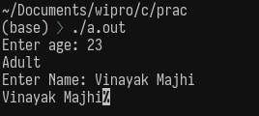

Q.2) largest of 3 numbers, where numbers are accepted by the user.

#include <stdio.h>

int main() {

int a, b, c;

printf("Enter 3 Numbers: ");
scanf("%d %d %d", &a, &b, &c);

if (a >= b && a >= c) {
printf("%d is the greatest", a);
}

else if (b >= a && b >= c) {
printf("%d is the greatest", b);
}

else {
printf("%d is the greatest", c);
}

return 0;
}

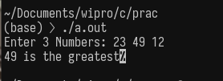

Q.3. Check whether the given Year is leap or not.

#include <stdio.h>

int main() {

int year;
printf("Enter year: ");
scanf("%d", &year);

if (year % 400 == 0) {
printf("Leap Year");
}

else if (year % 100 == 0) {
printf("Not a leap year");
}

else if (year % 4 == 0) {
printf("Leap Year");
}

else {
printf("Not a Leap Year");
}

return 0;
}

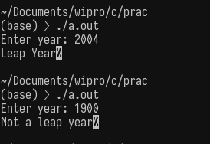

Operators:

----------

1. Sum of 2 numbers by accepting 2 numbers from the user.

#include <stdio.h>

int main() {

int a, b;

printf("Enter two numbers: ");
scanf("%d %d", &a, &b);

int sum = a + b;

printf("Sum is %d ", sum);

return 0;
}

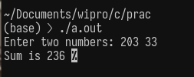

Q. 2) Simple Interest Calculator by accepting principal, rate and duration--> (P X R X T ) / 100 --> Interest.

Amount = Principal + Interest.

#include <stdio.h>

int main() {

int p, t;
float r;
printf("Enter Principal: ");
scanf("%d", &p);

printf("Enter Rate: ");
scanf("%f", &r);

printf("Enter Time Period: ");
scanf("%d", &t);
t = t / 12.0;

float interest = ((p * r * t) / 100);

float amount = p + interest;

printf("Amount = %f", amount);

return 0;
}

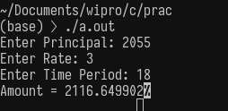

Q.3. Swapping 2 numbers using temporary variable

#include <stdio.h>

int main() {

int a, b, c;

printf("Enter 2 Nums: ");
scanf("%d %d", &a, &b);

printf("a = %d\n", a);
printf("b = %d\n", b);

c = a;
a = b;
b = c;

printf("a = %d\n", a);
printf("b = %d\n", b);

return 0;
}

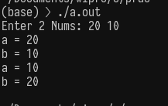

Nesting of Loops:

-----------------

Print the following patterns:

Where n is accepted from the user for number of lines

1. *

* *

* * *

* * * *

2.

1

1 2

1 2 3

1 2 3 4

3.

* * * *

* * *

* *

*

#include <stdio.h>

int main() {
int n = 0;
printf("Enter a num: ");
scanf("%d", &n);
for (int i = 0; i < n; i++) {
for (int j = 0; j <= i; j++) {

printf("* ");
}

printf("\n");
}

printf("\n---------------\n");

for (int a = 1; a <= n; a++) {
for (int b = 1; b <= a; b++) {
printf("%d ", b);
}
printf("\n");
}

printf("\n---------------\n");

for (int a = n; a > 0; a--) {
for (int b = a; b > 0; b--) {
printf("* ");
}
printf("\n");
}
return 0;
}

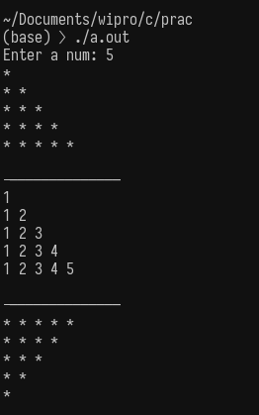

Problems on C Strings:
----------------------
Q.1. char str[] = "Have a lengthy string here"
Count the number of words, characters and spaces.

#include <stdio.h>

int main() {
char str[] = "This is using array indexing";
int i = 0;
int words = 0, chars = 0, spaces = 0;

while (str[i] != '\0') {
chars++;

if (str[i] == ' ')
spaces++;

if ((i == 0 && str[i] != ' ') || (str[i] != ' ' && str[i - 1] == ' '))
words++;

i++;
}

printf("String: %s\n", str);
printf("Characters: %d\n", chars);
printf("Spaces: %d\n", spaces);
printf("Words: %d\n", words);

return 0;
}
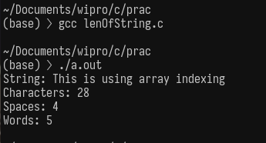

Using pointers

#include <stdio.h>

int main() {
char str[] = "this was done using pointers";
char *p = str;

int words = 0, chars = 0, spaces = 0;

while (*p != '\0') {
chars++;

if (*p == ' ')
spaces++;

if ((p == str && *p != ' ') || (*p != ' ' && *(p - 1) == ' '))
words++;

p++;
}

printf("String: %s\n", str);
printf("Characters: %d\n", chars);
printf("Spaces: %d\n", spaces);
printf("Words: %d\n", words);

return 0;
}

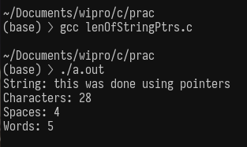

Q 2. Convert given string(short/lengthy) to
--> upper case
where all the characters are in upper case
--> lower case
where all the characters are in lower case
--> title case
where first character in each word is in upper case

#include <stdio.h>

void toUpper(char str[]) {
int i = 0;
while (str[i] != '\0') {
if (str[i] >= 'a' && str[i] <= 'z')
str[i] = str[i] - 32;
i++;
}
}

void toLower(char str[]) {
int i = 0;
while (str[i] != '\0') {
if (str[i] >= 'A' && str[i] <= 'Z')
str[i] = str[i] + 32;
i++;
}
}

void toTitle(char str[]) {
int i = 0;
int newWord = 1;

while (str[i] != '\0') {
if (str[i] == ' ') {
newWord = 1;
} else if (newWord && str[i] >= 'a' && str[i] <= 'z') {
str[i] = str[i] - 32;
newWord = 0;
} else if (!newWord && str[i] >= 'A' && str[i] <= 'Z') {
str[i] = str[i] + 32;
} else {
newWord = 0;
}
i++;
}
}

int main() {
char str1[] = "This is all an example using array indexing i'm doing";
char str2[] = "This is all an example using array indexing i'm doing";
char str3[] = "This is all an example using array indexing i'm doing";

toUpper(str1);
toLower(str2);
toTitle(str3);

printf("Upper Case : %s\n", str1);
printf("Lower Case : %s\n", str2);
printf("Title Case : %s\n", str3);

return 0;
}

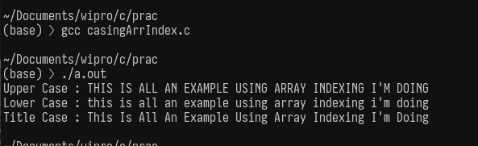
Using Pointers

#include <stdio.h>

void toUpper(char *p) {
while (*p != '\0') {
if (*p >= 'a' && *p <= 'z')
*p = *p - 32;
p++;
}
}

void toLower(char *p) {
while (*p != '\0') {
if (*p >= 'A' && *p <= 'Z')
*p = *p + 32;
p++;
}
}

void toTitle(char *p) {
int newWord = 1;

while (*p != '\0') {
if (*p == ' ') {
newWord = 1;
} else if (newWord && *p >= 'a' && *p <= 'z') {
*p = *p - 32;
newWord = 0;
} else if (!newWord && *p >= 'A' && *p <= 'Z') {
*p = *p + 32;
} else {
newWord = 0;
}
p++;
}
}

int main() {
char str1[] = "This is all an example using pointers i'm doing";
char str2[] = "This is all an example using pointers i'm doing";
char str3[] = "This is all an example using pointers i'm doing";

toUpper(str1);
toLower(str2);
toTitle(str3);

printf("Upper Case : %s\n", str1);
printf("Lower Case : %s\n", str2);
printf("Title Case : %s\n", str3);

return 0;
}

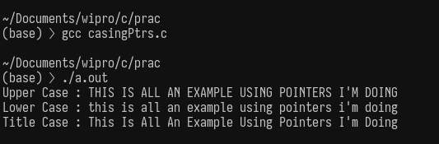

Q 3. Reverse a String.

#include <stdio.h>

void reverseString(char str[]) {
int i = 0, len = 0;
char temp;

while (str[len] != '\0')
len++;

for (i = 0; i < len / 2; i++) {
temp = str[i];
str[i] = str[len - i - 1];
str[len - i - 1] = temp;
}
}

int main() {
char str[] = "Vinayak here is typing this message! ";

reverseString(str);

printf("Reversed String: %s\n", str);

return 0;
}

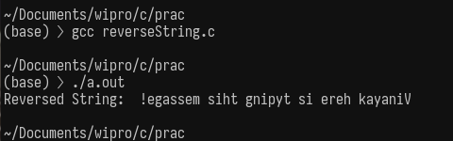

Q.4. Find and replace a substring in a lengthy string. here substring and replacement substring can be of different length.

#include <stdio.h>

void findAndReplace(char str[], char find[], char replace[]) {
char result[300];
int i = 0, k = 0;
int j, match;
int findLen = 0;

while (find[findLen] != '\0')
findLen++;

while (str[i] != '\0') {
match = 1;

for (j = 0; j < findLen; j++) {
if (str[i + j] != find[j]) {
match = 0;
break;
}
}

if (match) {
j = 0;
while (replace[j] != '\0') {
result[k++] = replace[j++];
}
i += findLen;
} else {
result[k++] = str[i++];
}
}

result[k] = '\0';

i = 0;
while (result[i] != '\0') {
str[i] = result[i];
i++;
}
str[i] = '\0';
}

int main() {
char str[300] = "This is a lengthy string example";
char find[] = "lengthy";
char replace[] = "short";

findAndReplace(str, find, replace);

printf("After Replacement: %s\n", str);

return 0;
}

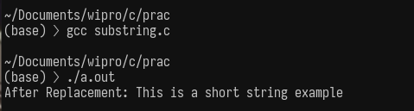

2 D Strings:
------------
Q. 1. Read the longest string from a collection of strings

#include <stdio.h>

int main() {
char str[5][100] = {"C programming", "Operating Systems", "Computer Networks",
"DBMS", "Data Structures and Algorithms"};

int i, j, maxLen = 0, index = 0, len;

for (i = 0; i < 5; i++) {
len = 0;
while (str[i][len] != '\0')
len++;

if (len > maxLen) {
maxLen = len;
index = i;
}
}

printf("Longest String: %s\n", str[index]);
printf("Length: %d\n", maxLen);

return 0;

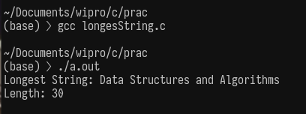

Q. 2. Sort names in alphabetical order

#include <stdio.h>

int main() {
char names[5][50] = {"Vinayak", "Sudhakar", "Harsh", "Anushka", "Souvik"};

char temp[50];
int i, j, k;

for (i = 0; i < 5 - 1; i++) {
for (j = i + 1; j < 5; j++) {

k = 0;
while (names[i][k] == names[j][k] && names[i][k] != '\0')
k++;

if (names[i][k] > names[j][k]) {
k = 0;
while (names[i][k] != '\0' || names[j][k] != '\0') {
temp[k] = names[i][k];
names[i][k] = names[j][k];
names[j][k] = temp[k];
k++;
}
temp[k] = names[i][k];
names[i][k] = names[j][k];
names[j][k] = temp[k];
}
}
}

printf("Sorted Names:\n");
for (i = 0; i < 5; i++)
printf("%s\n", names[i]);

return 0;
}

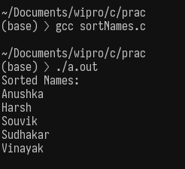

Q. 3. Accept a lenthy string as a string. Split each word and store them as separate string in a 2 D array.
(Converting 1 D to 2 D array)

#include <stdio.h>

int main() {
char str[200] = "C programming is very easy to learn";
char words[20][20];
int i = 0, row = 0, col = 0;

while (str[i] != '\0') {
if (str[i] == ' ') {
words[row][col] = '\0';
row++;
col = 0;
} else {
words[row][col] = str[i];
col++;
}
i++;
}
words[row][col] = '\0';

printf("Words stored in 2D array:\n");
for (i = 0; i <= row; i++)
printf("%s\n", words[i]);

return 0;
}

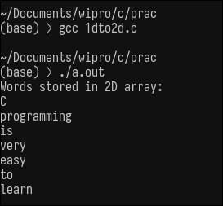

All the topic code c files has been uploaded to the code folder

